JAVA MOCK LAB TEST

Q1) Write an algorithm to determine if a number n is happy.
A happy number is a number defined by the following process:
- Starting with any positive integer, replace the number by the sum of the squares of its digits.
- Repeat the process until the number equals 1 (where it will stay), or it loops endlessly in a cycle which does not include 1.
- Those numbers for which this process ends in 1 are happy.
Return true if n is a happy number, and false if not.

import java.util.Scanner;

public class HappyNumber {

public static int HappyNum(String n)
{
int len = n.length();
int res=0;
for(int i=0; i<len; i++)
{
int val = (int)n.charAt(i) - '0';
res += val*val;
}
return res;
}

public static String convertToString(int num)
{
String res = "";

while(num!=0)
{
int rem = num%10;
res = rem + res;
num = num/10;
}
return res;
}

public static boolean IsHappy(String n)
{
int maxIter = 5;
boolean isFound = false;

for(int i=0; i<maxIter; i++)
{
int num = HappyNum(n);

if(num==1) {
isFound = true;
break;
}

n = convertToString(num);
}
return isFound;
}

public static void main(String[] args) {

Scanner obj = new Scanner(System.in);

System.out.print("Enter a number: ");
String n = obj.nextLine();

System.out.println(IsHappy(n));

obj.close();
}
}

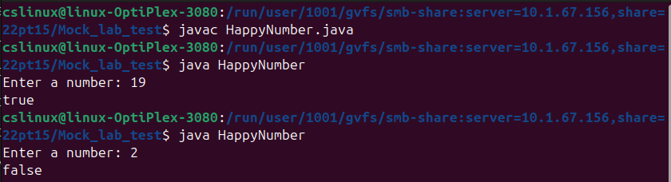

Q2) Given an array of strings words, return the words that can be typed using letters of the alphabet on only one row of American keyboard like the image below.
In the American keyboard:
the first row consists of the characters "qwertyuiop",
the second row consists of the characters "asdfghjkl", and
the third row consists of the characters "zxcvbnm".

import java.util.Scanner;

public class AmericanKeyboard {
public static void main(String[] args) {

Scanner obj = new Scanner(System.in);

String row1 = "qwertyuiop";
String row2 = "asdfghjkl";
String row3 = "zxcvbnm";
String[] rows = {row1, row2, row3};

System.out.print("Enter the no. of words in arr: ");
int n = obj.nextInt();

String[] words = new String[n];
System.out.println("Enter the words: ");
for(int i=0; i<n; i++) {
words[i] = obj.next();
}
System.out.println();

String[] res = new String[n];
int r_i = 0;

for(int i=0; i<n; i++)
{
String word = words[i].toLowerCase();
boolean flag = true;

char ch = word.charAt(0);
int index;
if(row1.indexOf(ch)!=-1)
index = 0;
else if(row2.indexOf(ch)!=-1)
index = 1;
else
index = 2;

for(int j=0; j<word.length(); j++) {
ch = word.charAt(j);
if(rows[index].indexOf(ch) == -1) {
flag = false;
break;
}
}

if(flag) {
res[r_i++] = word;
}
}

System.out.println("Words that can be typed using only one row of keyboard: ");
for (String word : res) {
if(word != null)
System.out.println(word);
}

obj.close();

}
}

